

Type 2 Diabetes
Group Education Learning
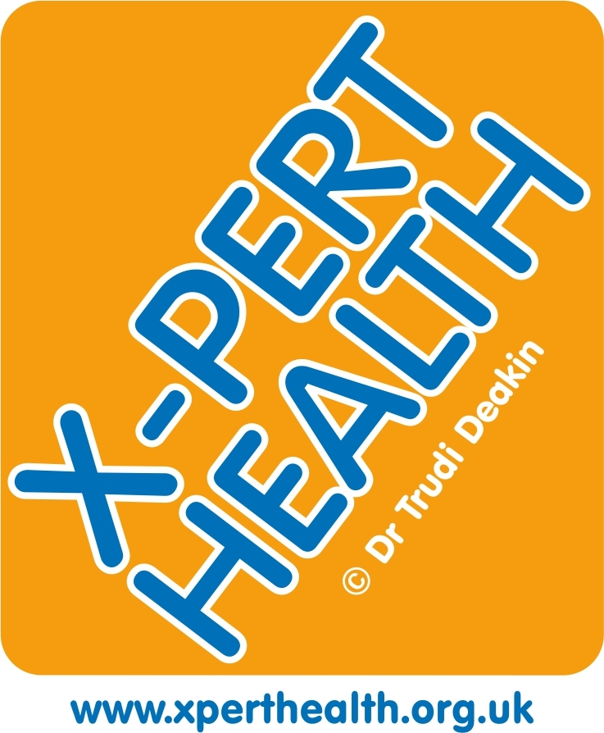

X-PERT
A highly effective, evidence based course - proven to improve quality of life,self-management skills and health outcomes
For more information visit: http://www.xperthealth.org.uk/

education programme

e

X-PERT is delivered over five / six once weekly group sessions However you have the option to attend as many sessions as you wish but for full benefit it is recommended to complete the course.
Due to CV-19 restrictions we are currently delivering this course online. In the future we hope to resume face to face sessions .
The online sessions are delivered by trained educators and the learning is interactive and you have opportunity to ask questions.
The sessions are delivered via Microsoft Teams . You will need access to a laptop or Smart Phone or tablet.
Once you complete the course you will receive by post a comprehensive X-PERT handbook and You Tube video links to all the sessions.
The course covers:
- Understanding Diabetes,reversal of Diabetes
- Dietary approaches and Weight Management
- Carbohydrate Awareness
- Healthy shopping tips/Understanding food labels/Physical activity and exercise/Psychology of eating.
- Long term health complications and Foot-care
- Are you an X-PERT? Summary and Conclusions

To Register for the course
Please complete this form and email to:
hrch.diabeteseducationhounslow@nhs.net

I have Type 2 Diabetes and would like to attend X-PERT
Full name and title: …………………………………………………
Date of birth:…………………………………
NHS Number…………………………….
Address: ………………………………………
………………………………………………….
Postcode: ……………
Day time telephone or mobile number:
…………………………………..
E-mail Address: …………………………………..
I prefer sessions in the (delete as appropriate):

Morning Afternoon Evening

The sessions are delivered in English. If you have any language needs please email our service to discuss other options.

Please turn over and also complete page 4

